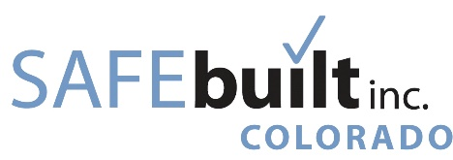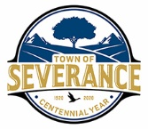
Building Department

IMPORTANT NEWS

Town of Severance - New Codes Adopted

2021 IPC | 2023 NEC
The State of Colorado Plumbing Board has adopted the 2021 International Plumbing Code requiring the Town of Severance to adopt and enforce compliance.  https://dpo.colorado.gov | The State of Colorado Electrical Board will adopt the 2023 National Electrical Code on August 1, 2023, the Town of Severance will start full enforcement of the 2023 NEC on January 1, 2024  https://dpo.colorado.gov

